COSC 1337

Lab 8 – OO-Thinking

**\*10.5**(*Check palindrome*) Write the following function to check whether a string is a palindrome assuming letters are case-insensitive:

**bool** isPalindrome(**const** string& s)

Write a test program that reads a string and displays whether it is a palindrome. Here are some sample runs:

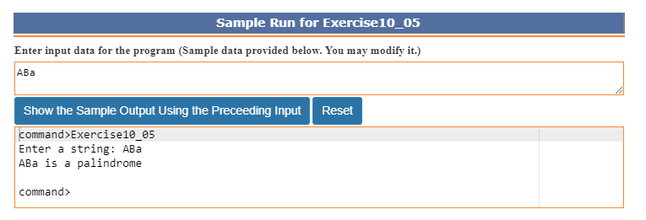

**\*\*10.9**(*The* *Location* *class)* Design a class named Location for locating a maximal value and its location in a two-dimensional array. The class contains public data fields row, column, and maxValue that store the maximal value and its indices in a two dimensional array with row and column as int type and maxValue as double type.

Write the following function that returns the location of the largest element in a two-dimensional array. Assume that the column size is fixed.

**const int** ROW_SIZE = 3;

**const int** COLUMN_SIZE = 4;

Location locateLargest(**const double** a[][COLUMN_SIZE]);

The return value is an instance of Location. Write a test program that prompts the user to enter a two-dimensional array and displays the location of the largest element in the array. Here is a sample run:

